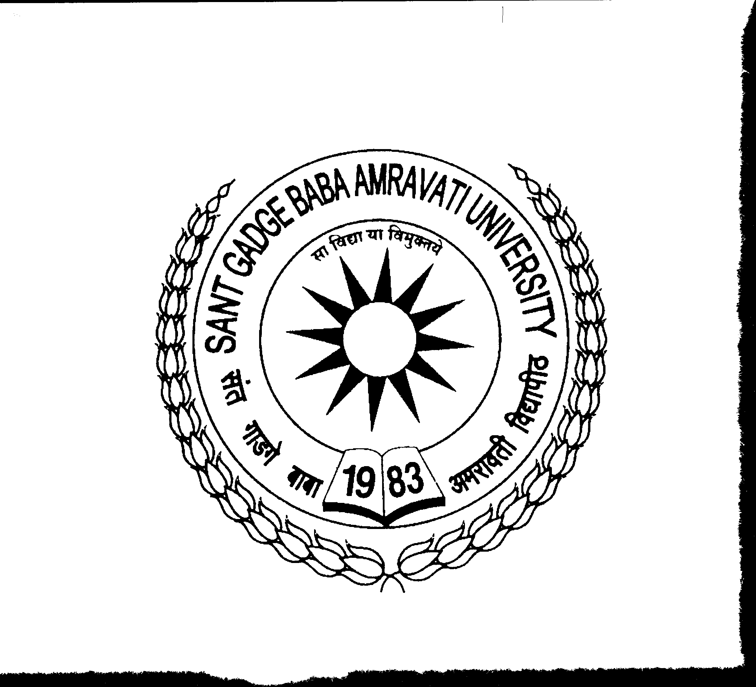
SANT GADGE BABA AMRAVATI UNIVERSITY, AMRAVATI
UGC – HUMAN RESOURCE DEVELOPMENT CENTRE
FACULTY DEVELOPMENT CELL

Website: www.ascsgbau.ac.in Phone : 0091-721- 2668174 Email: directorhrdc@sgbau.ac.in

APPLICATION FORM FOR TRAIN THE TRAINER PROGRAMME
(Scheduled between 30th Dec. 2019 to 04th Jan. 2020)

Registration Fees Details

UGC – HRDC Receipt No. / Demand Draft No. | Date | Amount
 |  | 3000/-

1. Name: Dr./Mrs./Miss/Mr. : _________________________________________________

2. Designation : _________________________________________________

3. College/Institute Address : _________________________________________________

_________________________________________________

4. Educational Qualifications : _________________________________________________

(area of specialization _____________________________)

(Teaching experience in years________________________)

5. Contact Details : STD Code ________ Office _______________________

: Mobile _______________________ Fax_______________

: E-mail __________________________________________

5. Gender : Male Female Transgender

6. Category : SC ST GENERAL

7. Whether NCC/NSS Co-ordinator : Yes No

8. Whether he/she is ICT tools user : Yes No

9. Are you training /placement officer in your college? : Yes No

10. Have you attended such kind of training? : Yes No

,,
Declaration of Applicant
I hereby declare that all information furnished in this application form is true, complete and correct to the best of my knowledge and belief. I understand that in the event of any information being found false, incomplete or incorrect, my application/admission is liable to be rejected/cancelled at any time.

Place _______________

Date _______________ (Signature of the Applicant)

ENDORSMENT BY AUTHORITY

I recommend that Dr./Mr./Mrs. ___________________________(Designation)______________ (Institution)_____________________________________________________________________ interested to participate in Train the Trainer Programme during 30th Dec. 2019 to 04th Jan. 2020 and he/she will be relived on the time to participate in the above programme at UGC – HRDC, Sant Gadge Baba Amravati University, Amravati, if selected. This is also certify that the details mentioned in the application form by him/her were verified and found correct.

Place: _______________

Date: ________________ Signature of Principal
With Seal

Instruction for Filling up Application

- Incomplete form will not be entertained
- The completed application form with duly endosured by Principal should be sent to the address within last date given below.
To,
The Director
UGC – Human Resource Development Centre,
Sant Gadge Baba Amravati University, Amravati,
Pin code – 444602.
- No TA/DA will be paid to the teacher participants. However, the host institution will provide facility of boarding at free of cost. Lodging facility will provide at UGC–HRDC guest house and it is chargeable as per UGC – HRDC norms.
- Certificate will be awarded only on successful completion along with online feedback submission process of the Course. Attendance in all sessions of the course is compulsory. The UGC-HRDC may disallow or withheld certificate on valid reasons including shortage of attendance.
- The teacher participant will have to pay Rs.3000/- (Rs. Three thousand only) by cash or demand draft mode along with application form. Without registration fees application will not be entertained. The demand draft should be in favour of The Finance & Account Officer, SGBAU, Amravati.

