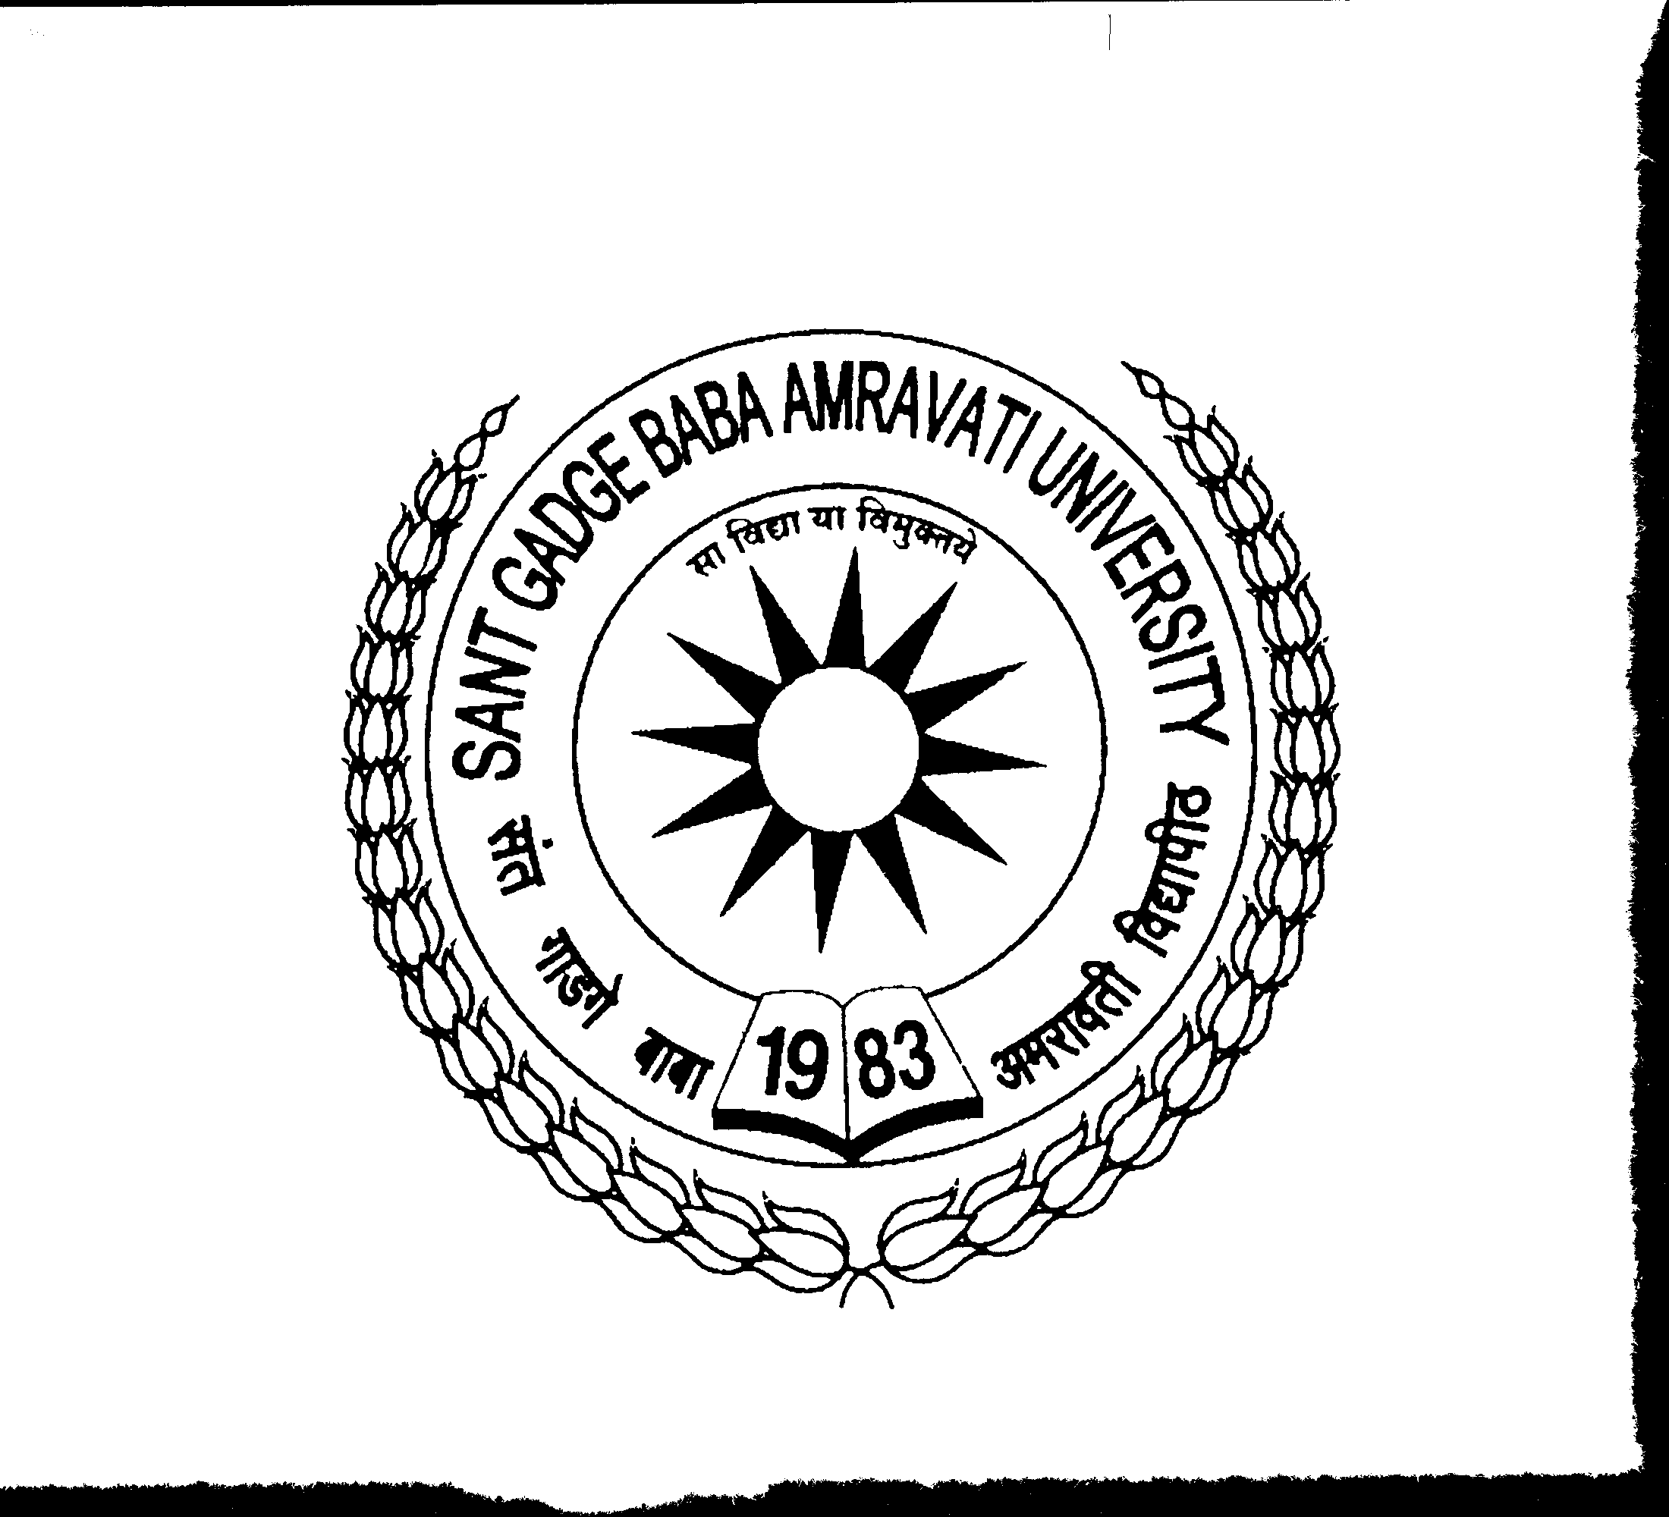NAAC Accredited ‘A’ Grade University
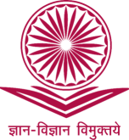
Sant Gadge Baba Amravati University, Amravati.
University Grants Commission, New - Delhi.

Website: www.ascsgbau.ac.in Ph. No.: 91-721-2668174 Email: directorhrdc@sgbau.ac.in

No: SGBAU/UGC-HRDC/230/2020
Date: 17th Feb. 2020

Sub: Organization of Sophisticated Instrumental Training Workshop for affiliated college teachers…

Sir/Madam,
As per the direction mentioned in perspective plan of University, this has to inform you that, three days workshops on “Sophisticated Instrumental Training cum Hands on” for affiliated college teachers in the category of Basic Sciences is scheduled to be organized during 5th – 07th March 2020. The UGC – Human Resource Development Centre, Sant Gadge Baba Amravati University is inviting application forms of interested Assistant Professors from your esteem institution in prescribed proforma enclosed herewith. The eminent resource persons from various industries and research institutes will be invited for these workshops. The workshop will be beneficial for the participants to acquire theoretical & practical knowledge as well as to improve skills for handling modern analytical instruments. Moreover, to train the trainers in training technology to help them deliver their subject-specific training in a systematic manner so that they build up creativity, knowledge construction, learning environment, teaching strategies, problem solving skills and understanding concepts using various tools.
Therefore, you are kindly requested to depute/nominate one faculty members among the category of Basic Sciences to participate in this workshop. The last date for receiving application will be 28th Feb. 2020. No registration fees shall be charged from teachers to participate in this workshop.
With warm regards,

Sd/-
Director (I/c.)
UGC – Human Resource Development Centre
Sant Gadge Baba Amravati University
Enclosure: Application Form

To,
All principals,
All affiliated college of University.

